**WEB INFORMATION MANAGEMENT (WIM)**

# **1. Introduction to a website**

There’s a parallelism between a website and a shop. In both of them there’s a window (hompage) that shows what the website/shop contains/sells.

What do the people expect from a homepage? Many things, but the most important is the **information**. The problem of information synthesis has not invented with web pages … it’s a problem common in *information communication*, the problem has born with journal articles.

The information components of a home page:

* **WHERE?** Where did I (user) arrive?
* **WHO?** Who is behind the website?
* **WHY?** What are the benefits? Why should I stay?
* **WHAT?** What choices do I have?
* **WHEN?** What are the last news?
* **HOW?** How do I arrive to where I want?

That’s the **core of informatio**n, what the people want to know. If these parts are missing the information is uncompleted. Users want to know this information.

We need to convince the user to surf on our website.

**But** that’s not so easy to fill the homepage with this information. There’s a “small” problem… **TIME!** Users have expectations and have **limited time**. It’s easy to put put everything on a webpage but people don’t have the time to read/see everything.

A user arrives to our home page and he spend, on average, **31 seconds**. So we have on average 31 seconds of time to convince the user to stay in our site, and show him the information components. And the way to do it is to **compress the information**.

For example, *how much text can we put in our home page?* It depends from how much faster the people read but on average from **200 to 300 words per minute which go down to 180 in case of computer screen reader** because it reads slowly than a human.

So if we put more than 93 words we have finished our time. They should be quite less, because the user doesn’t spend all of the time just to read, but there is also time lost to analyze the visual layout, images, links and more.

**We want not only he coming to our site, we want him to coming back!** So what about the returing user? Same expectations? He knows you already, so the limited time for the home page will not used the axes WHERE, WHO and WHY. The time will be spent only on the remaing axes, WHAT, WHEN and HOW.

**The disadvantages of returning is more demanding**, and he has less time to spend for us.

Time on homepage: first visit (31 seconds) / second visit (25 seconds) / third visit (22 seconds) …

So if we want to make our returning users happy, we have a little treasure of **19 seconds** four our homepage, to split among the WHAT, WHEN and HOW parts. That is a maximum of **57 words for all these components**. He will skip the parts that he already know.

I have to open a website and obtain the main information from the webpage, try with this:

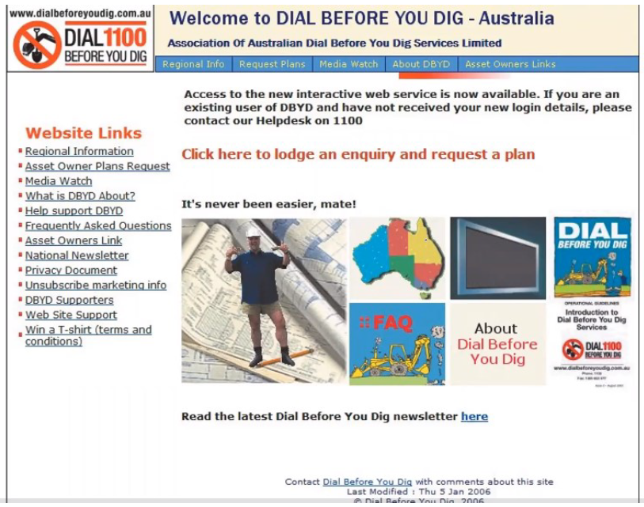

**Too hard! It’s not clear!**

We can do better:

